**Name: Rajnedra Prasath**

**Contact: rajendra.prasath@iiits.in**

**Linkedin:**

**Website:** [**http://www.iiits.ac.in/people/regular-faculty/dr-rajendra-prasath/**](http://www.iiits.ac.in/people/regular-faculty/dr-rajendra-prasath/)

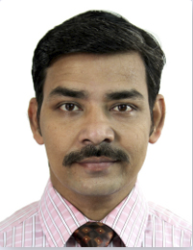

Dr. Rajendra Prasath, Bestowing his interests in the fields of Machine Learning, Business Intelligence Modelling, Information Retrieval, basically everything trending the industry, and inspiring students like us. He has been into teaching with Data Structures, Computer Programming and Algorithms.

Dr. Prasath has won achievements in Best Short Paper Award, AIRS 2013; Visiting Fellowship Norway, NTNU; MHRD Research Fellowship, IIT Kharagpur; Adhoc Trach Coordinator in FIRE 2011 and many more. He has worked on publishing books on Intelligent Computer Communication and Processing, Approaches in Interconnection Networks, Intuitive algorithm for rotation about an arbitrary axis and many, from span of 2013 to till date, and has worked on his research and teaching from 2018 in IIIT Sri City and inspiring us.